These test papers are copyright and must not be reproduced in any way.
©
This paper should be withdrawn after use in the examination or classroom and retained by the teacher.
Test papers may not be used for private tutoring in the year of publication.



PHYSICS

YEAR 11

2004

INSTRUCTIONS TO CANDIDATES

TIME: 2½ Hour Paper: MARKS: 165

Attempt questions 1 to 15 Section A
Attempt questions 1 to 6 Section B
Attempt question 1 Section C

TIME: 3 Hour Paper: MARKS: 200

Attempt ALL questions

STRUCTURE OF THE PAPER

Section | No. of  Questions | No. of questions  to be attempted | No. of marks  out of 200 | Proportion of  exam total
A: Short Answers | 15 | ALL | 60 | 30%
B: Problem Solving | 7 | ALL | 100 | 50%
C: Comprehension and  Interpretation | 2 | ALL | 40 | 20%

Note: Above refers to 3 hour paper. For less than 3 hours refer to front cover.

INSTRUCTIONS TO CANDIDATES

Write your answers in the spaces provided beneath each question. The value of each question (out of 200) is shown following each question.

The enclosed Physics: Formulae and Constants Sheet may be removed from the booklet and used as required.

Calculators satisfying conditions set by the Curriculum Council may be used to evaluate numerical answers.

Answers to questions involving calculations should be evaluated and given in decimal form. Quote the final answer to not more than four significant figures. Despite an incorrect final result, credit may be obtained for method and working, providing these are clearly and legibly set out.

Questions containing specific instructions to show working should be answered with a complete, logical, clear sequence of reasoning showing how the final answer was arrived at; correct answers which do not show working will not be awarded full marks.

Questions containing the instruction "Estimate" may give insufficient numerical data for their solution. Students should provide appropriate figures to enable an approximate solution to be obtained.
Section A: Short Answers

Marks allocated: 60 marks out of a total of 200 (30%)

Attempt ALL 15 questions in this section. Each question is worth 4 marks.
Answers are to be written in the space below or next to each question.

1 A tennis ball of mass 60.0 g has a velocity of 15.0 m s⁻¹ to the west when it makes contact with a tennis racquet. After contact, it leaves the racquet with a velocity of 15.0 m s⁻¹ to the east.

Determine the change in momentum of the tennis ball during the time it was struck by the racquet.

2 An egg of mass 58.0 g is dropped from a height of 1.5 m onto a floor.

a) Assuming air resistance is negligible, calculate the momentum of the egg just before impact.

b) The egg is now placed in a container that crumples on impact. Explain why this type of container makes it far less likely that the egg will break.

3 (a) A student is provided with a freshly prepared sample of a radioactive material and the count rate C from the source is found to vary with time t as shown in Fig. (a).

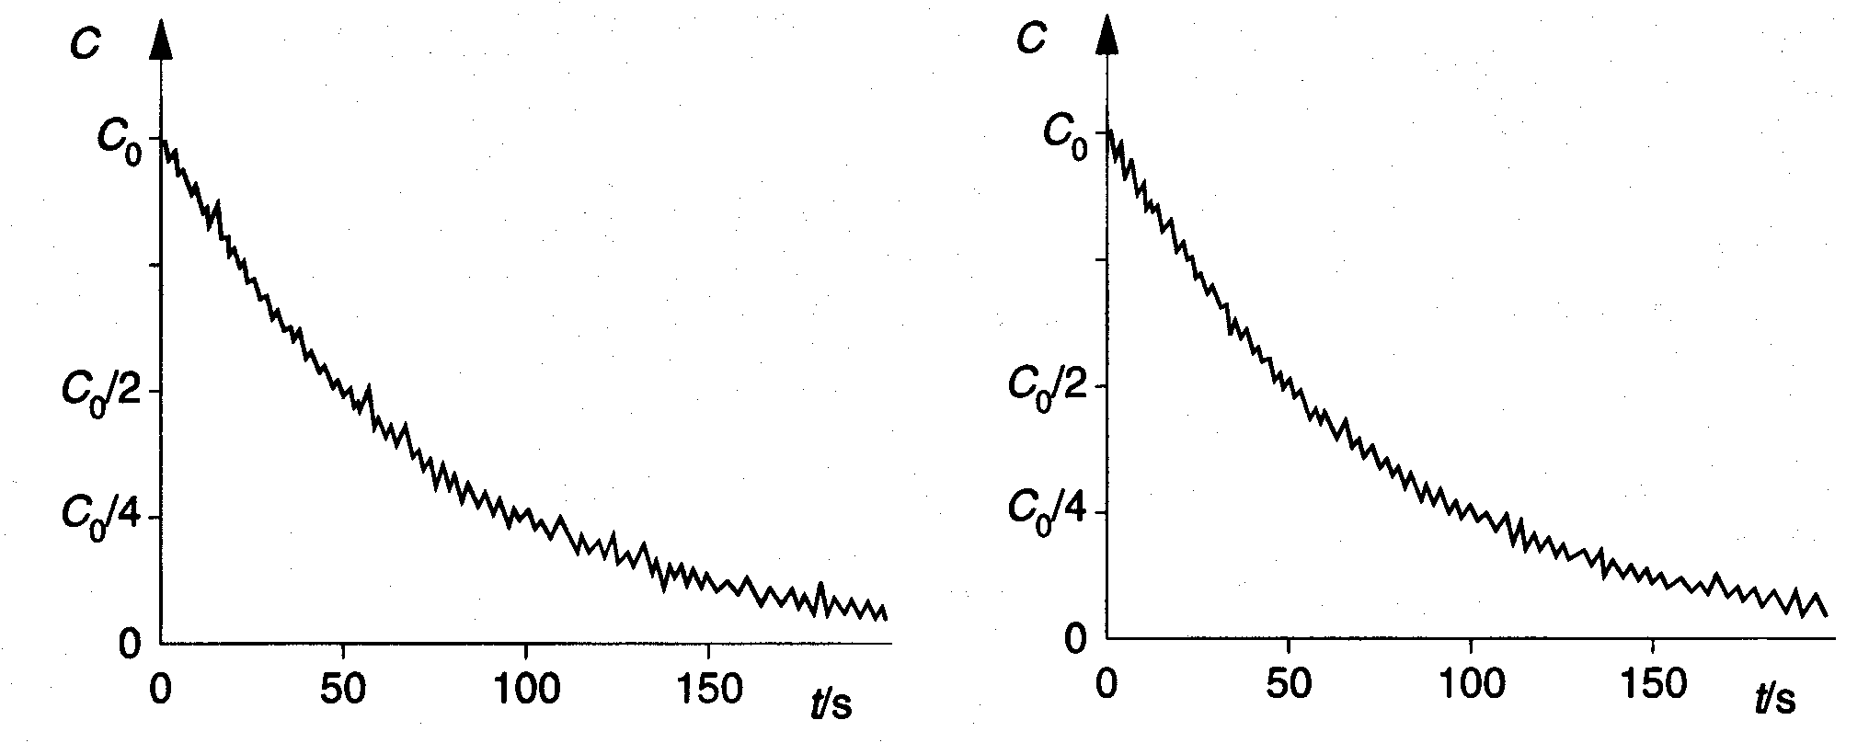
Fig (a) Fig (b)

A second similar sample of the radioactive material is then prepared and the student repeats the experiment, but with the sample at a higher temperature. The variation with time of the count rate for the second sample is shown in Fig. (b).

State the evidence that is provided by these two experiments for

(i) the random nature of radioactive decay,

- the spontaneous nature of radioactive decay.

- A worker using sources should wear a film badge (a dosimeter) on his or her chest:
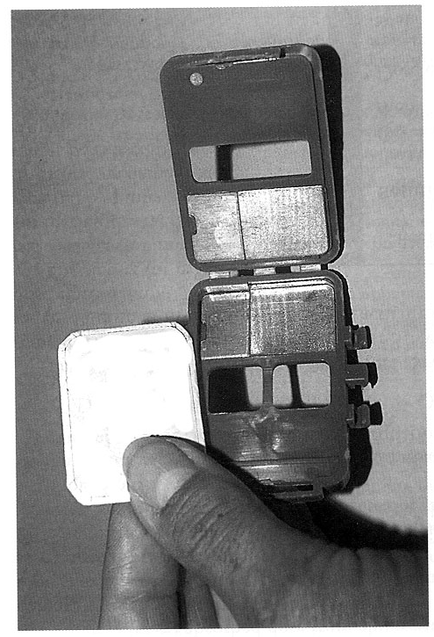

How would this show an exposure to beta-radiation? Explain briefly.

4 A heating element for an electric heater consists of a single strand of nichrome wire wound around an insulator. The heater is required to produce 1.2 kW when connected to the 240 V AC mains.

a) Calculate the working resistance of the nichrome wire.

b) List two factors that affect the resistance the nichrome wire offers to the electrical current.

5 An area of land is an average of 2.0 m below sea level. To prevent flooding, pumps are used to lift rainwater up to sea level.

What is the minimum pump output power required to deal with 1.3 x 10⁹ kg of rain per day?

6 A mine worker receives a cumulative dose of alpha and beta radiation every day for 25 days. The total absorbed dose of alpha is 8 mGy each day and the beta dose is 32 mGy each day, what is the total dose equivalent received?

7 The filling of a hot meat pie always seems hotter than the pie’s pastry. Explain why.

8 The diagram below shows part of the decay series for radon - 222. The half lives of radon and daughters is also shown. Use the decay series to write balanced nuclear equations for the following decays.
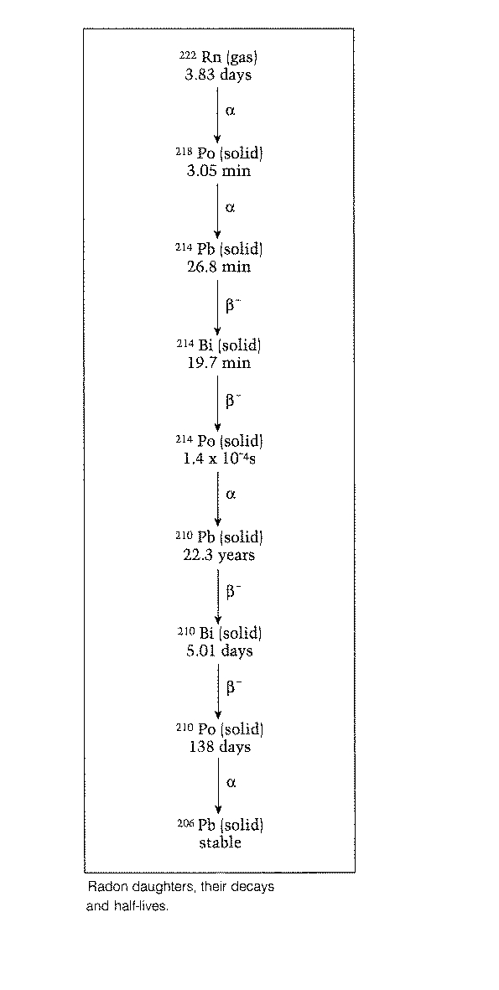
(a) Bi – 210 decaying to Po – 210

(b) Po – 210 decaying to Pb - 206

9 (a) State a use for a convex mirror.

(b) With the aid of a ray diagram explain what is meant by chromatic aberration of lenses.

10 A man loading goods onto a storage platform rolls a 220.0 kg barrel up a ramp, inclined at 23° to the horizontal, on to the platform that is 1.85 m off the ground.

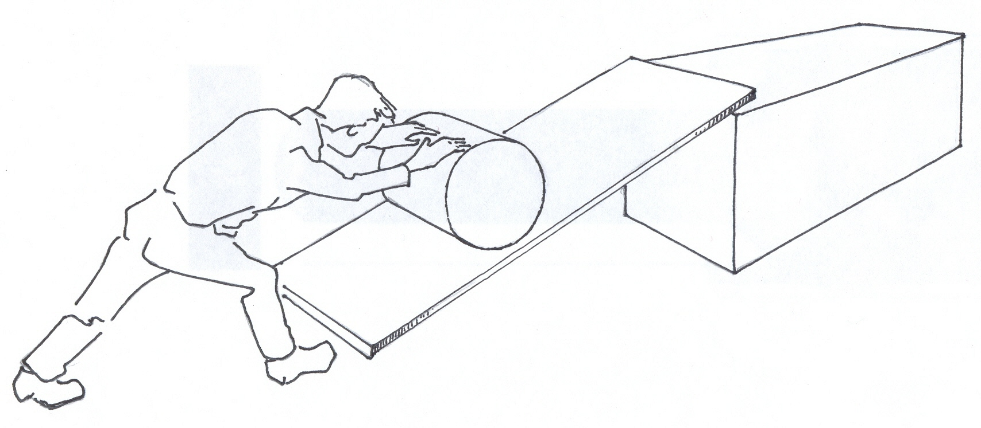

a) What minimum average force will he have to exert on each barrel?

b) If the average force of friction between the barrel and the ramp is 65 N, what force must he exert?

11 Fluorescent lights are often covered with white, translucent plastic. What is the function of the cover?

- The graph below shows how the displacement of a toy train moving in a straight line varies over a period of time.
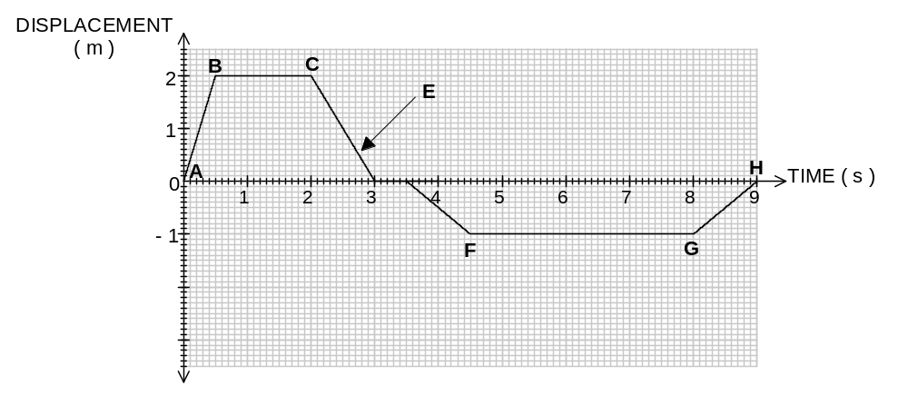

a) What is the maximum speed attained by the train?

Answer: ________________

b) Describe the motion of the train in section
(i) BC

(ii) E

c) What is the total length of track used by the train in the above journey?

Answer: ________________
13 A ray of light passes from air, through glass into water.
(a) Sketch the path of the ray as it passes into the glass and then into the water.
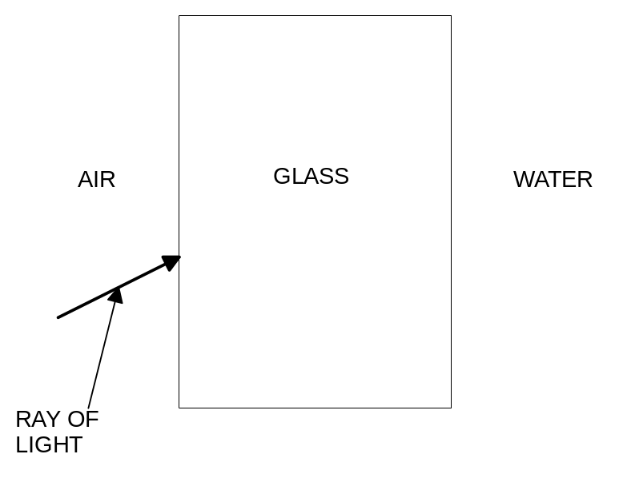
(b) State what happens to the velocity, frequency and wavelength by using the words increases, decreases or remains the same as the ray passes from air into the glass.

Velocity

Frequency

Wavelength

14 An electric water chiller containing 200.0 kg of water cools the water from 25.0°C to 15.0°C in 3.00 hours.

Calculate
a) the energy lost by the water as it cools to 15.0°C.

(b) the power output of the chiller in kW.

15 Two charges K and L, of magnitude +5 x 10^{–3} C and -5 x 10^{–3} C respectively, are placed at two corners of a triangle, as shown in the figure below.

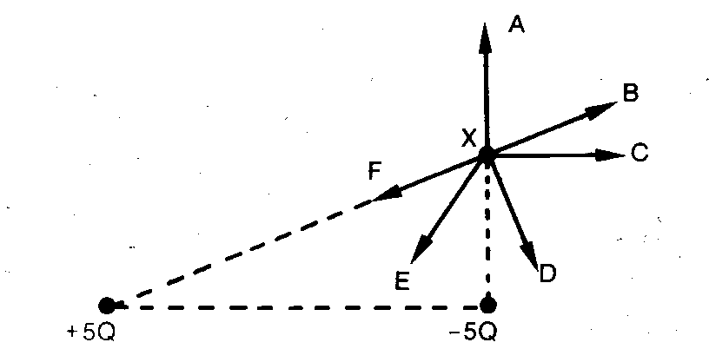
+5 x 10^{–3} C
K
-5 x 10^{–3} C
L

a) What direction (A, B, C, D, E or F) will the electric field have at X?

Answer: ____________

- Explain why you have chosen the answer to 15 a) above.

Section B: Problem Solving

Marks allotted: 100 marks out of a total of 200 (50%)

This section contains 7 questions.

You should answer: ALL of the questions 1, 2, 3, 4, 5, 6 and 7

Answer the questions in the spaces provided.

(14 marks)
(a) A student attempts to simulate the cooling cycle of steam after it has been used in the electrical generator of a nuclear reactor. Super-heated steam at 110°C is blown into 0.20 kg of water at 20.0°C contained in a 0.25 kg glass beaker as shown. Find the increase in the mass of water when its temperature rises to 80.0°C. (10 marks)
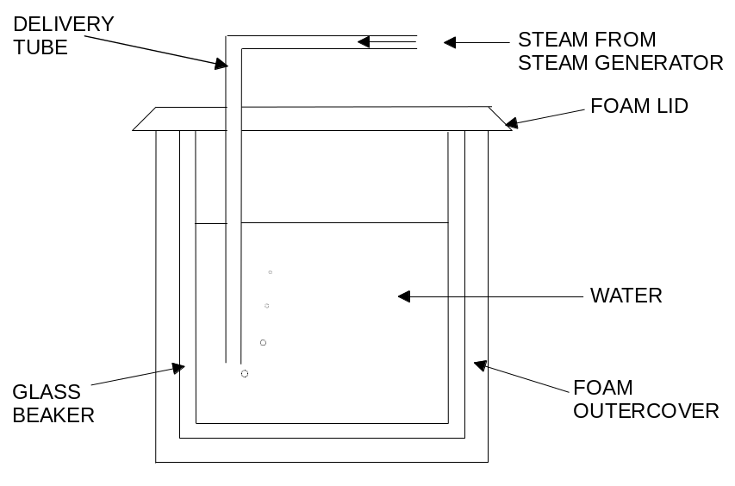

(b)
Two plastic cups are placed one inside the other. Hot water is poured into the inner cup and a lid is put on top as shown.

Which statement is correct?
(2 marks)
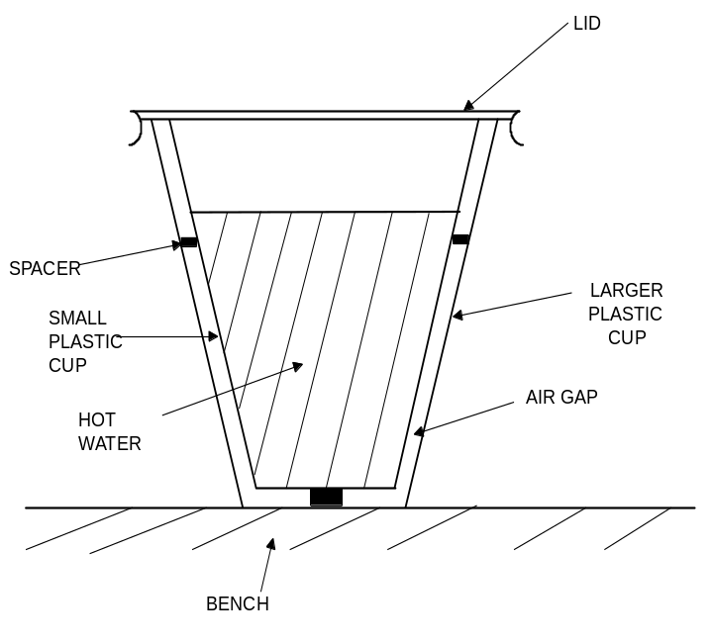

A Heat loss by radiation is prevented by the small air gap.
B No heat passes through the sides of either cup.
C The bench is heated by convection from the bottom of the outer cup.
D The lid is used to reduce heat loss by convection.

(c) A bar is made of aluminium, copper and cast iron as shown in the diagram below. The cast iron section of the bar is heated evenly for a short time and temperatures at points A and B are measured. The temperature at A is 88º C and the temperature at B is 87º C
What does this demonstrate about the conductivities of aluminium and copper?
(2 marks)
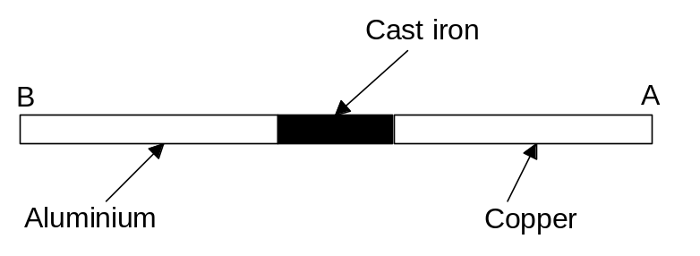

2 (16 marks))
(a) In a thermal reactor, induced fission is caused by the U–235 nucleus capturing a neutron, undergoing fission and producing more neutrons. Which one of the following statements is true?

A To sustain the reaction a large number of neutrons is required per fission.
B The purpose of the moderator is to absorb all the heat produced.
C The neutrons required for induced fission of U–235 should be slow neutrons.
D The purpose of the control rods is to slow down neutrons to thermal speeds.
(1 mark)

(b) An unstable isotope of uranium may split into a caesium nucleus, a rubidium nucleus and some neutrons in the following process.

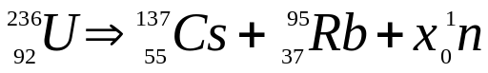

(i) Determine the value of X, ie the number of neutrons produced, in the above process.
(1 mark)

(ii) Calculate the energy, in joules, released in the above process given the following nuclear masses together with data from the Formula and Constants Sheet. (4 marks)
mass of a nucleus of Cs–137 = 136.87688 u
mass of a nucleus of Rb–95 = 94.19481 u

(iii) If the energy released is shared equally by the neutrons as kinetic energy, at what speed do they travel upon emission? (4 marks)

(c) A radioactive source is used to test the thickness of paper. The source is put on one side of the paper and the Geiger counter on the other side. The paper rolls from the papermaking plant onto the roller as shown.
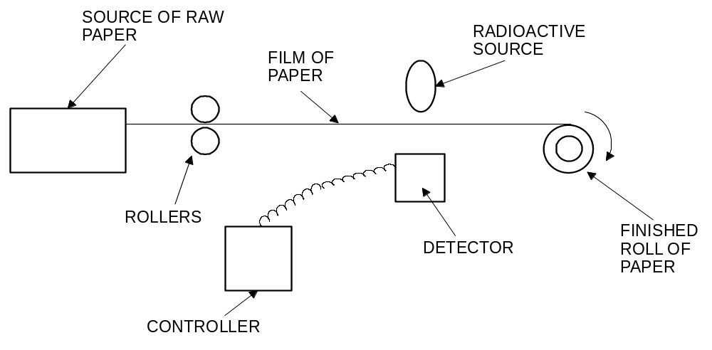

(i) Why are beta particles more suitable than alpha particles or gamma rays for this job?
(2 marks)

The table shows the reading on the counter during 70 s.

times in seconds | 10 | 20 | 30 | 40 | 50 | 60 | 70
total count since the start | 50 | 100 | 150 | 195 | 235 | 275 | 315
count in 10 seconds | 50 | 50 | 50 | 45 | 40 | 40 | 40

(ii) Look at the table of results. What happened to the thickness of the paper? Explain (2 marks)

(iii) The isotope used in the above process has a half life of 5.50 years. If a new sample of the isotope used has a count rate of 1500 counts per minute and is only useful with count rate over 240 counts per minute, approximately how long will the sample last before it needs to be replaced? (2 marks)

3 (15 marks)
(a) A factory uses a beam of light to allow workers to visually check the temperature of a liquid.
A semi-circular crown glass ( n = 1.75 ) block is placed in a liquid X whose refractive index n changes with temperature T (in °C) according to the formula

n = 2.25 - 0.025 T

A light ray directed to the centre of the glass block makes an angle θ = 60.0° with the normal
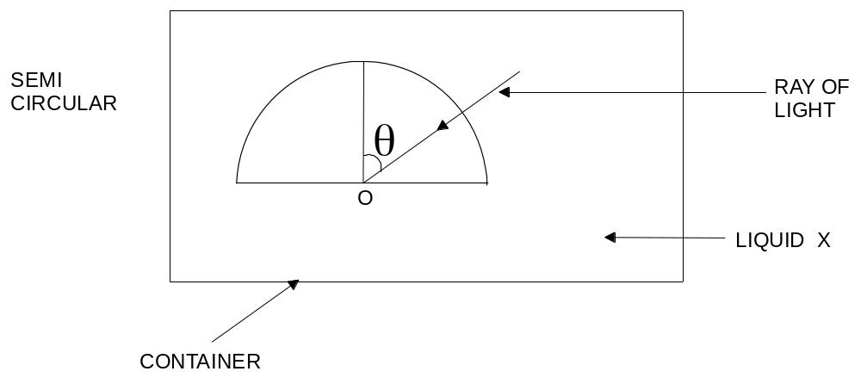

(i) If the ray is just totally reflected at O, find the refractive index and the corresponding temperature of liquid X. (5 marks)

(ii) Draw on the diagram above, the refracted ray at T = 20.0°C (3 marks)

(iii) Calculate the speed of light in the liquid X at T = 20.0°C (3 marks)

(iv) If θ is kept at 60° and the temperature is raised slowly from 10°C to 50°C. Describe the movement of the refracted ray. Explain briefly.
(4 marks)

4 (10 marks)
A traffic investigator comes upon the scene of an accident on a road where the speed limit is
70 km h^{–1}, and observes a damaged car at rest. A skid mark leading to the car is 50.0 m long.
The investigator knows that the mass of this car is 1.25 tonnes and that the frictional braking force when skidding was approximately 12 500 N. From this evidence she is able to estimate the speed of the car immediately before the driver applied the brakes.

a) Assuming a constant braking force, calculate the speed of the car just before the driver applied the brakes. Show your working.
(5 marks)

b) Was the car speeding? Justify your answer. (2 marks)

c) How long did it take the car to stop? (3 marks)

5 (18 marks)
(a) X and Y are two lamps connected in parallel as part of a shop window display. X is rated at 12 V, 24 W and Y at 6.0 V, 18 W. Calculate the current through each lamp and the resistance of each lamp when it operates at its rated voltage.
(4 marks)

X:

Y:

(b) The two lamps are connected in the circuit shown. The battery has an emf of 27 V and its internal resistance is negligible. The resistors R_{l} and R₂ are chosen so that the lamps are operating at their rated voltage.
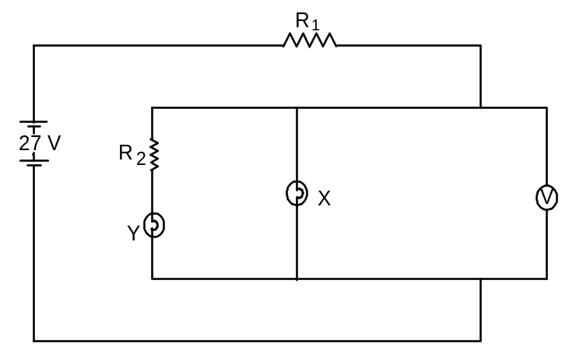

(i) What is the reading on the voltmeter? (2 marks)

(ii) Calculate the resistance of R₂. (2 marks)

(iii) Calculate the current through R₁. (2 marks)

(iv) Calculate the voltage across R₁. (2 marks)

(v) Calculate the resistance of R₁. (2 marks)

(vi) Calculate the resistance of the parallel section of the circuit. (2 marks)

(vii) Calculate the heat dissipated in the battery during 5.0 minutes of operation.
(2 marks)

6 (12 marks)
A roller coaster at a festival is set up by a carriage being hauled to the top by an electric motor. The mass of the carriage and the people is 505.0 kg and the vertical height is 31.0 m

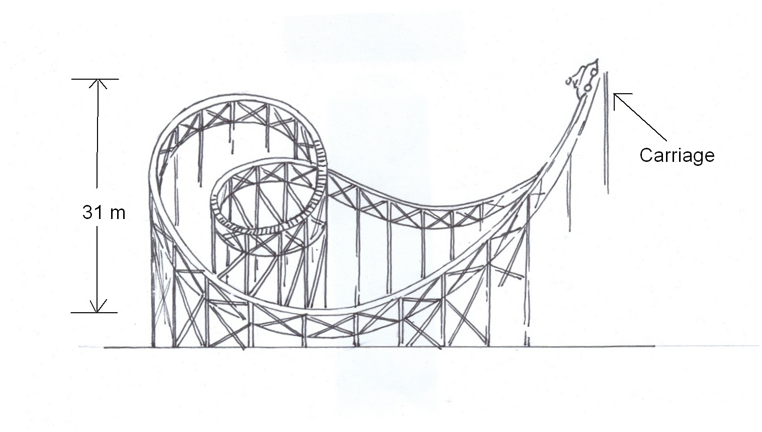

a) Calculate the potential energy of the carriage at the beginning of the ride.
(2 marks)

b) The car is then released and goes down the slope that is 70.0 m long, where the average frictional force is 30.00 N. What is the speed of the car when it reaches the bottom?
(4 marks)

c) What is the momentum of the carriage at the bottom of the slope? (2 marks)

d) The diagram shows a loop of the ride lower in height to the beginning of the ride. Briefly comment upon this. (2 marks)

e) What maximum vertical height could the carriage reach after moving through the bottom
of the loop? (2 marks)

7 (15 marks)
An electron travelling horizontally in a vacuum enters the region between two horizontal metal plates, as shown below.

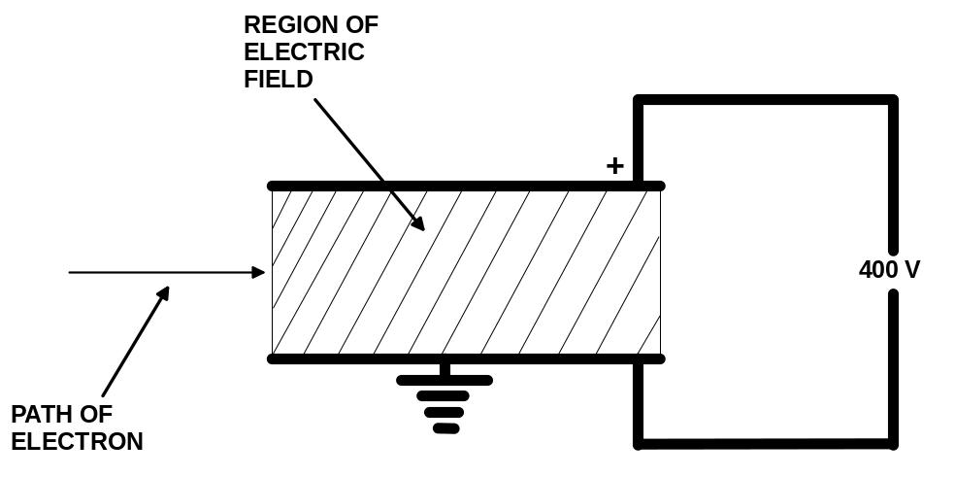

The lower plate is earthed and the upper plate is at a potential of + 400 V. The separation of the plates is 0.80 cm.

The electric field between the plates may be assumed to be uniform and outside the plates to be zero.

a) On the diagram, sketch the path of the fast moving electron as it passes between the plates and beyond them.
(3 marks)

b) (i) On the diagram, sketch the electric field between the plates.
(2 marks)

(ii) How much energy (in joules) does the electron have if it travels from the earthed plate to the positive plate?
(2 marks)

c) If the electron is subjected to a force of 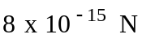, what is its acceleration?
(2 marks)

d) If the electron is travelling in air rather than a vacuum will its acceleration be changed?
Explain. (2 marks)

e) If the electron is travelling at 90% the speed of light when it enters the electric field, calculate the momentum of the electron. (2 marks)

f) If the electron is travelling at the same speed when it leaves the electric field will its momentum have changed? Explain. (2 marks)
Section C: Comprehension and Interpretation

Marks allotted: 40 marks out of 200 (20%)

BOTH questions should be attempted. Each question is worth 20 marks.

Question 1

Solar Electricity
Paragraph 1
Alternative energy sources have been discussed for decades and some of the proposals are now in place. One source that has been investigated but is still to be implemented is using the sun’s energy directly- where it always shines – in space. The most ambitious of all projects is a solar collector in stationary orbit above the earth. At a height of 3.59 x 10⁷ m above the earth there would be 1.4 kW m⁻² of power available compared to 1.0 kW m⁻² at best on the earth’s surface.

Paragraph 2
At this height gravitational forces are low and there would be no weather problem and there would be only brief 'black-outs' (about 70 min.) as the satellite is eclipsed. The present proposal for the space powered station envisages two panels 5.9 km x 4.9 km covered by solar cells. The two panels together would have a power output of 9.50 x 10³ MW. Between the two panels would be a microwave transmitting antenna. The panels would face the sun continually, while the microwave antenna would rotate once each day, with respect to the panels, to face the receiving station. The input of
9.50 x 10³ MW would result in an effective power input at the receiving antenna on earth of about
5.0 x 10³ MW. This can be compared with Australia’s largest conventional power station that has a power output of 1.5 x 10³ MW

Paragraph 3
The earth power station would need an antenna covering about 270 square km. This will be about 80% transparent and raised above the ground, impervious to rain and no barrier to productive use of the land beneath it. The materials required for the construction are in plentiful supply. The energy for building the satellite and placing it into orbit would be regenerated in about three years according to estimates.
Probably the most expensive part of the enterprise would be the transport of the component parts into space and assembly in space. Each complete power station would need 60 to 100 individual flights of heavy-lift launch vehicles. It has been suggested that some of the components could be manufactured in space.

Paragraph 4
Large land areas would be required for plantations intended to produce fuels for power, for arrays of solar cells or for collectors for electricity generations. This is due to the diffuse nature of solar radiation as compared with concentrated energy sources. For example, burning fossil fuels raises the temperature of a boiler to between 400 º and 600 ºC and being a concentrated source it requires only a small contact surface to transfer energy from the source to the boiler.

Questions

  - Why is solar radiation said to be diffuse? (para 4) (2 marks)

- For the solar space power station to be successful it is important that there are no ‘weather problems’. How would ‘weather problems’ effect the functioning of the station? (para 2)
(2 marks)

- Draw a two dimensional diagram to show how a ‘blackout’ would occur. (para 2) (3 marks)

- What would be the function of the transmitting antenna? (para 2) (2 marks)

- Why is it important that the power station is in a stationary orbit around the earth? (para 1)
(2 marks)

6 Calculate the power output per square metre of the proposed solar panels in space. (para 2) (3 marks)

7 What does the statement; “The energy for building the satellite and placing it into orbit would be regenerated in about three years according to estimates.” mean? (para 3) (2 marks)

8 Which power station, a large conventional station or a solar station, would produce the most energy in a 24 hour period? Support your answer with calculations. (para 2) (2 marks)

9 Why would a solar power station at a height of 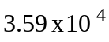km above the earth receive more power than a solar power station situated on the earth’s surface? (2 marks)

Question 2 Fission and Fusion Bombs

Para 1
In the early '1950's', a new type of nuclear bomb was developed: the fusion bomb, or hydrogen bomb. This type of bomb uses reactions in which very light nuclei are fused (joined together). Just as in the case of fission of heavy nuclei, this releases a large quantity of energy. Tritium and deuterium are fused into alpha particles and neutrons with the release of 27.8 x 10⁻¹³ J of energy. A second example fusion reaction involves the fusion of two nuclei of deuterium which produces tritium and protons and 6.4 x 10⁻¹³ J of energy. Fusion bombs are frequently referred to as hydrogen bombs.

Para 2
The above reaction equations show that what occurs in fusion is the joining together of positively charged atomic nuclei. Fusion only occurs when these nuclei are compacted together very closely (to a distance of approximately 10 ⁻¹⁵ m). To achieve this the repulsing electrical force must be counteracted. This can only happen when the nuclei have a very great speed and this requires temperatures of millions of degrees Kelvin. In the fusion bomb these very high temperatures are achieved through the explosion of a fission bomb. The fusion bomb is therefore always a fission-fusion bomb. Fusion bombs can have a very large explosive force of up to 50 mega tonnes of TNT.

Para 3
Fusion of light atomic nuclei takes place in the sun. It is the origin of sunlight. For many years attempts have been made in laboratories to use this fusion process for the generation of electrical energy. This requires very high densities of the gas mixtures, which contain the nuclei that are to be fused, as well as very high temperatures. Economically viable fusion reactors are unlikely to become available during the next few decades.

Para 4
One of the effects of the explosion of a nuclear weapon is nuclear radiation. A distinction can be made between direct (prompt) radiation and subsequent (delayed) radiation. Direct radiation occurs within one minute of the explosion. It consists of alpha, beta, gamma and neutron radiation. Only the last two types are important because alpha and beta radiation are absorbed in air over a very short distance. The range of gamma and neutron radiation is longer, but it is also limited by absorption in air. The degree of absorption is given in the table below which shows the dose equivalent received in the first minute after the explosion.

Dose equivalent (Sv) | Distance form explosion (km)
10 | 2.5
5 | 2.7
1 | 3.1

Para 5
Apart from the direct radiation of a nuclear explosion it is necessary to take account of delayed radiation - the fallout. Fallout consists of two types of substances:
- Fission products - these derive immediately from the fission of heavy atomic nuclei; most of them emit beta and gamma radiation;
- New radioactive substances - neutrons produced by nuclear reactions are also 'caught' by other nuclei, causing these to become radioactive and, usually, to become beta and gamma emitters.
Para 6
Fission products are formed in all atomic bomb explosions.
Important nuclides are Cs-137 and Sr-90, with half-lives of 30 and 28 years respectively. Of these
Sr-90 is the most dangerous because its properties resemble those of calcium. This may have serious consequences, especially in children, because of their strong growth. An increase of Sr-90 in milk was one of the reasons for halting nuclear tests in the atmosphere. The second type of fallout occurs mainly in explosions of nuclear bombs close to the ground. In this case the neutron radiation, produced by the bomb, irradiates many materials. The radioactive substances so formed are evaporated by the heat of the explosion and are sucked high into the atmosphere. After condensation, they eventually return to the earth's surface.

Questions

- Write a nuclear equation showing how tritium and deuterium are fused into alpha particles and neutrons (para 2) (2 marks)

2 How many single fusion reactions involving the fusion of tritium and deuterium would be required to produce one joule of energy? (para 1) (2 marks)

- Why are fusion bombs frequently referred to as hydrogen bombs? (para 1) (2 marks)

- Explain why the fission bomb was developed before the fusion bomb? (para 2) (2 marks)

5 Sr – 90 has properties similar to calcium. Why is this particularly significant with respect to children’s health? (para 6) (2 marks)

- What is meant by the term ‘irradiates many materials’ (para 6) (2 marks)

- How many years would it take for Cs – 137 to reduce to 1/16 th of its original activity? (para 6) (2 marks)

8 After a fortnight, the activity of the fallout from a nuclear bomb is only about 0.1% of the initial fallout (30 minutes after the explosion). Why does this reduction in fallout occur? (para 5) (2 marks)

9 List the two factors that have delayed the development of a fusion process that could be used to produce electricity. (para 3) (2 marks)

10 Use the table in paragraph 4 and information from the Formula and Constants Sheet to calculate the absorbed dose of a child who has been irradiated by alpha radiation 2.5 km from a nuclear explosion. (para 4) (2 marks)

END OF 3 HOUR EXAMINATION

